Project Document

APIs Used and Integration

APIs Used:
- Random.org API: Provides true random numbers generated via atmospheric noise. Integrated using fetch('https://api.random.org/json-rpc/2/invoke', {/* ... */}) to generate random numbers for the dice roll .
- Open Trivia DB API: Supplies quiz/trivia questions from a global database. Used by making requests such as fetch('https://opentdb.com/api.php?amount=10&type=multiple') to get random multiple-choice questions for our game.

Integration Example:
Each API call was made using JavaScript’s fetch API, and responses were parsed and presented to users dynamically. The resulting traffic was captured and analyzed in Wireshark by filtering for tls (HTTPS) and http.request packets.

Reflections

TCP vs TLS Handshake
- TCP handshake (SYN, SYN-ACK, ACK) quickly establishes the socket-level connection. TLS handshake negotiates security, takes longer, and exchanges certificates—critical for HTTPS APIs like Random.org and Open Trivia DB.

DNS Resolution and Latency
- DNS queries to random.org and opentdb.com resolve quickly on Wi-Fi (typically under 50ms), often slower on mobile hotspot due to added network hops.

Caching and Network Load
- Calling Random.org or Open Trivia DB with identical parameters may trigger caching (evidenced by 304 Not Modified responses, ETag/Cache-Control headers).
- Changing parameters (like quiz category or amount) generates new API calls and bypasses cache, increasing network load visible in Wireshark as new full payloads.

Wi-Fi vs Mobile Hotspot Latency
- Wi-Fi shows lower, more stable latency; mobile hotspot networks have more variable, usually higher round-trip times for DNS, TCP handshake, TLS handshake, and API request/response

Screenshots

- TCP Capture
- TLS Capture
- DNS Resolution
- DNS Flow
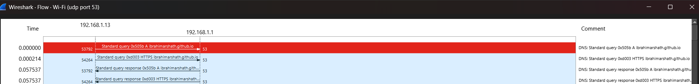

- Website

